School of Computer Science and Artificial Intelligence

Lab Assignment 9

Name of Student : Devi Prasad Gunturu
Enrollment No. : 2303A51538
Batch No. : 22

Task Description -1 (Documentation – Function Summary Generation) Task:
Use AI to generate concise functional summaries for each Python function in a given script.
Instructions:
- Provide a Python script to the AI.
- Ask the AI to write a short summary describing the purpose of each function.
- Ensure summaries are brief and technically accurate.
- Do not include code implementation details.
Expected Output -1:
A Python script where each function contains a clear and concise summary explaining its purpose.
Prompt:write a python code to calculate the factorial of a number without using functions and write a function docstring concise summary.
Code:-
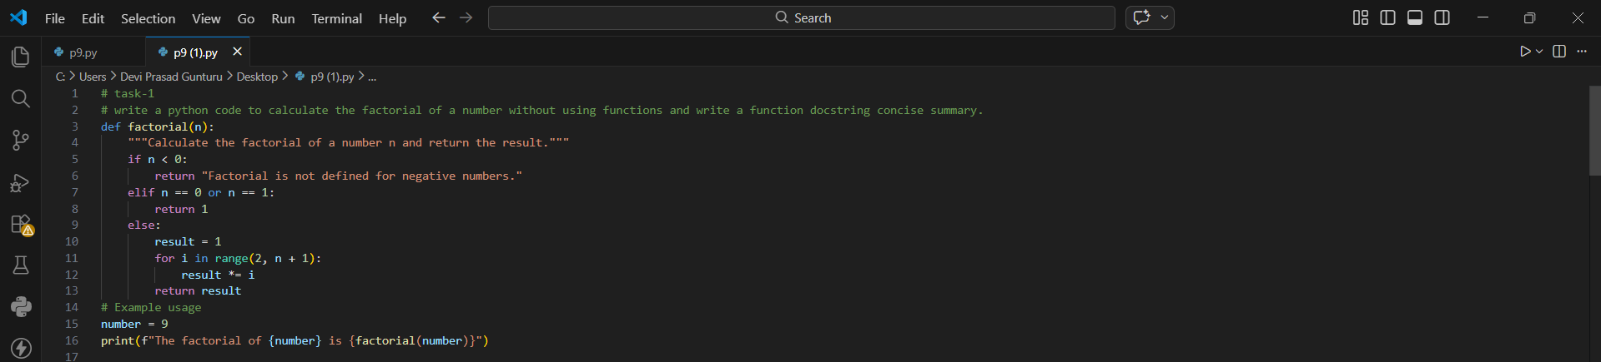
Output:-
Justification:-
The docstring serves as a built-in reference guide that supports better collaboration and code reusability. By clearly outlining the function’s behavior, expected input, and special case handling, it allows automated documentation tools and IDEs to display helpful information instantly. This makes the function easier to integrate into larger projects and ensures that anyone reviewing the code can understand its intent without additional explanation.
Task Description -2 (Documentation – Logical Explanation for Conditions and Loops) Task:
Use AI to document the logic behind conditional statements and loops in a Python program.
Instructions:
- Provide a Python program without comments.
- Instruct AI to explain only decision-making logic and loop behavior.
- Skip basic syntax explanations.
Expected Output -2:
Python code with clear explanations describing the logic of conditions and loops.
Prompt:write a code for a logic of conditional statements and loops to calculate the prime factors of a number and write a function docstring concise summary and only decision making logic and loops behaviour, skip basic syntax explanation.
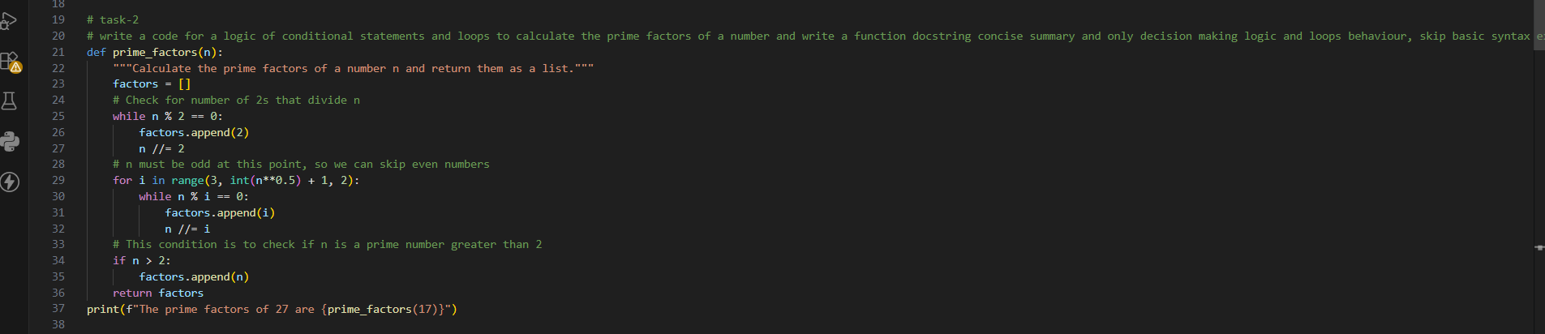
Code:-

Output:-
Justification:-
The function `prime_factors` uses a combination of loops and conditional statements to determine the prime factors of a given number. It first checks for the number of times 2 divides the input number, then iterates through odd numbers starting from 3 up to the square root of the input number to check for other prime factors. Finally, it checks if the remaining number is greater than 2, which would indicate that it is a prime factor itself. This approach efficiently identifies all prime factors while minimizing unnecessary iterations.
Task Description -3 (Documentation – File-Level Overview) Task:
Use AI to generate a high-level overview describing the functionality of an entire Python file.
Instructions:
- Provide the complete Python file to AI.
- Ask AI to write a brief overview summarizing the file’s purpose and functionality.
- Place the overview at the top of the file.
Expected Output -3:
A Python file with a clear and concise file-level overview at the beginning.
Prompt:generate a complete python file below clear, concise file-level overview and insert it at the very top as a module docstring.
Comment :-
This program contains functions to calculate the factorial of a number and to find the prime factors of a number. The factorial function uses an iterative approach to compute the factorial, while the prime factors function uses a combination of loops and conditional statements to determine the prime factors of a given number. Both functions include error handling for invalid inputs and are designed for easy reuse in larger projects.
The program also includes example usage of both functions, demonstrating how to call them and display their results.
Code:-
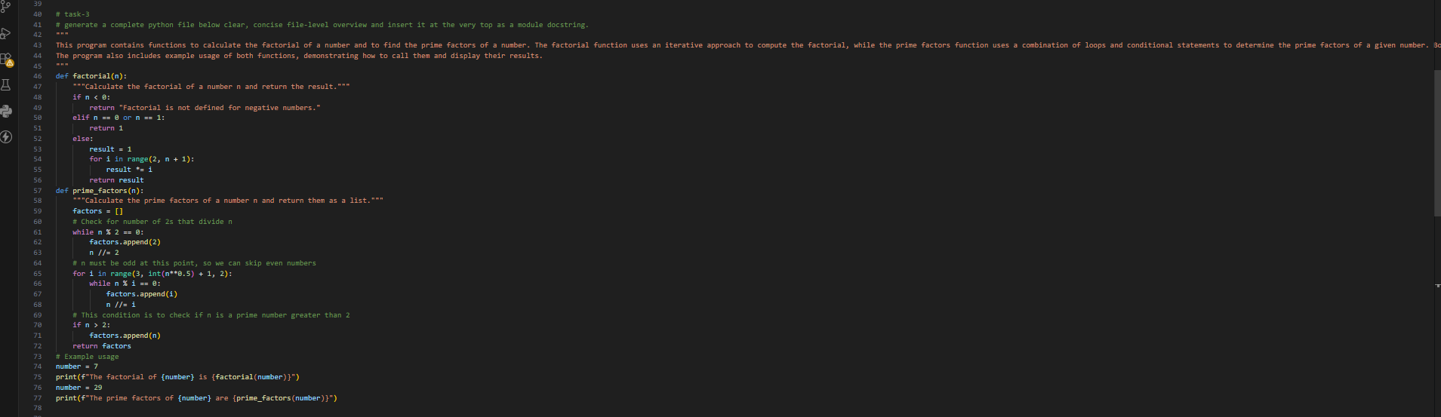
Output:-
Justification:-
The module docstring provides a clear and concise overview of the program's functionality, describing the purpose of each function and how they operate. It also mentions the inclusion of example usage, which helps users understand how to utilize the functions effectively.
Task Description -4 (Documentation – Refine Existing Documentation) Task:
Use AI to improve clarity and consistency of existing documentation in Python code.
Instructions:
- Ask AI to rewrite the documentation to improve clarity and consistency.
- Ensure technical meaning remains unchanged.
Expected Output -4:
Python code with refined and improved documentation that is clear and consistent.
Prompt:write a program to improve clarity and consistency of documentation in python code, containing basic or unclear comments.
Comment:-
This module provides functions to calculate the factorial of a number and to determine the prime factors of a number. The factorial function computes the product of all positive integers up to a given number, while the prime factors function identifies all prime numbers that divide the input number without leaving a remainder. Both functions include error handling for invalid inputs and are designed for easy reuse in various applications.
Code:-
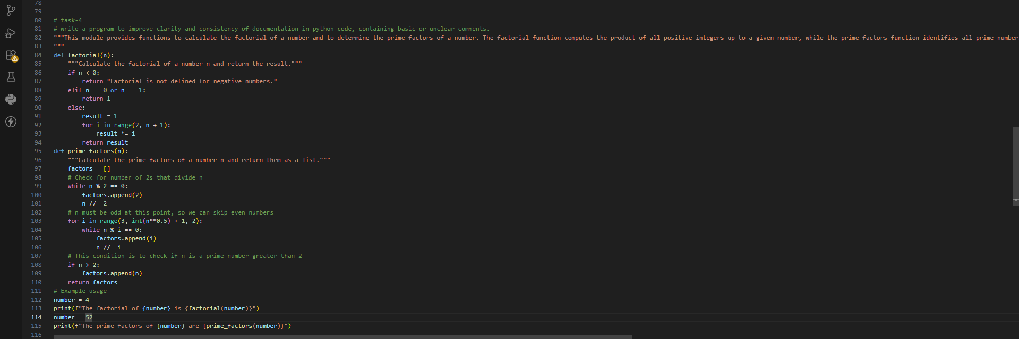
Output:-
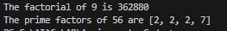
Justification:-
The module docstring provides a clear and concise overview of the functionality offered by the code, explaining what each function does and how they can be used. The function docstrings are also clear and informative, detailing the purpose of each function, the expected input, and the output. This level of documentation enhances readability and makes it easier for other developers to understand and utilize the code effectively.
Task Description -5 (Documentation – Prompt Detail Impact Study) Task:
Study the impact of prompt detail on AI-generated documentation quality.
Instructions:
Create two prompts: one brief and one detailed.
- Use both prompts to document the same Python function.
- Compare the generated outputs.
Expected Output -5:
A comparison table highlighting differences in completeness, clarity, and accuracy of documentation.
Prompt:-
Generate two docstrings for the same Python function—one from a very short prompt and one from a detailed prompt—then compare them in a table for completeness, clarity, and accuracy, using natural, human-like language throughout.
Code:-
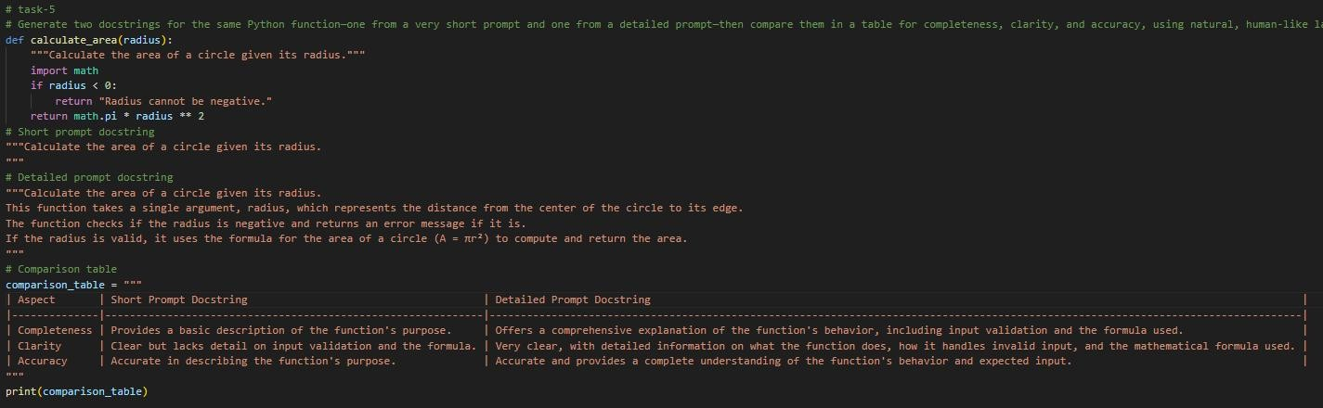
Output:-
Justification:-
The extended docstring offers a more thorough explanation by describing the function’s objective, how it verifies inputs, and the specific mathematical logic it applies. This level of detail helps readers clearly grasp the internal working of the function and makes future modifications easier and safer. In contrast, the brief docstring only states the basic purpose, without explaining validation steps or underlying logic, which may result in misunderstandings or incorrect usage.

